Group 5: Through the Lens

# **Intro to the Topic**

Team 5 presents Through the Lens - a look at films and what drives their success. Success can be defined in two ways for this project: critical acclaim and profit. This project looks at patterns in film, seeking to understand which factors contribute to a film’s success.

Users will be able to predict a film’s critical success based on certain criteria, interact with a dashboard to explore the financial success of different films, and see the way films are rated on Rotten Tomatoes.

# **Inspiration**

[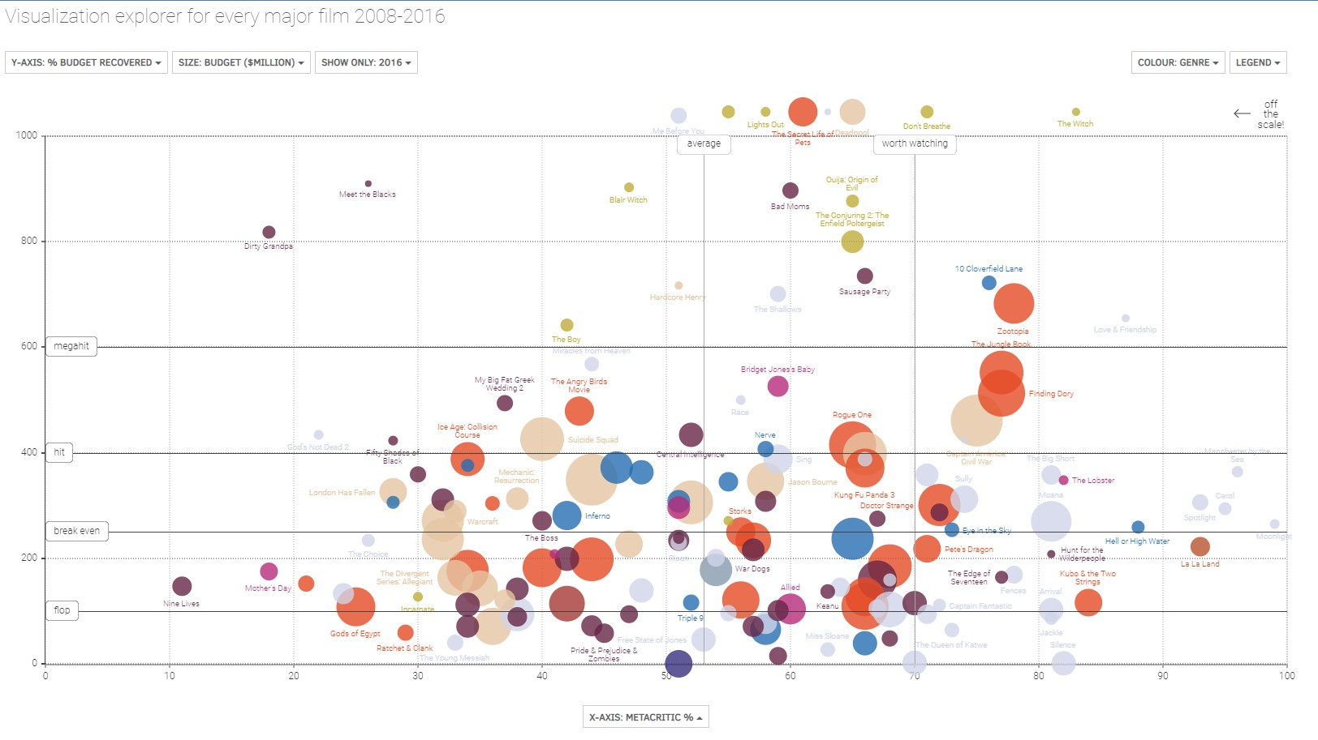](https://www.informationisbeautiful.net/visualizations/the-hollywood-insider/)

As our team discussed potential project ideas, movies just clicked for all of us. When we began our research, the most inspiring dashboards had the following in common: distinct color stories and tons of character, static and interactive visuals working in tandem, and fantastic dots that moved across the screen as you adjusted variables (see the image above.)

We sought out film data and settled into exploring Rotten Tomatoes scores and Box Office Mojo financial data.

# **Expectations**

Going into the project, we did not have any major expectations, but rather a few things we were curious about. Ratings and genre had us pondering what would be the most successful, and questioning the potential for ratings like R or NC17 to draw in large enough audiences or repeat views to compete with the films with broader audiences.

**Data Sources**

[Box Office Mojo](https://www.kaggle.com/datasets/igorkirko/wwwboxofficemojocom-movies-with-budget-listed)

[Rotten Tomatoes](https://www.kaggle.com/datasets/stefanoleone992/rotten-tomatoes-movies-and-critic-reviews-dataset)

**Tools Required**

* Python and Jupyter Notebook.
* Pandas, Numpy, Scikit-learn.
* Linear Regression, Random forest, LGB, and GB Regressor for model prediction.
* SQLite for Database
* Tableau for Dashboards
* HTML,CSS,Java Script for web page

**EDA**

Exploratory data analysis is performed on the Box Office Mojo budget update dataset. We have found that there are 3243 entries and 26 columns. We have columns like movie title, year, mpaa, release date, runtime, distributor, writer, producer, composer, main actors, genre, budget, domestic, international, and worldwide.

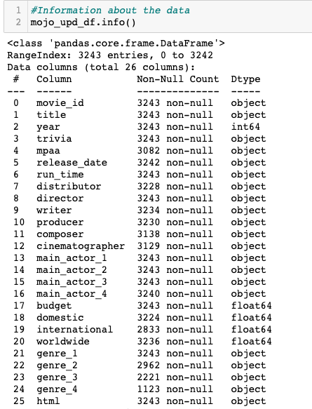

The initial data set with incomplete information or null values are ﬁxed as follows:

1. Deleting the rows with null values.
2. Dropping the unnecessary columns.

This is the cleaned dataset we have used for analyzing the data:

# 

The runtime is converted into minutes. When we see the mean runtime of all the genres, we can see that Biography has a long runtime by comparison.

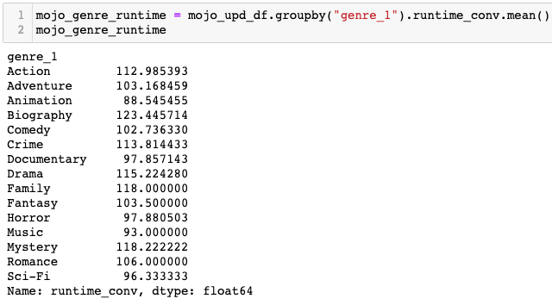

The runtime for each genre is plotted by using barchart. We could see that Drama’s have a longer runtime.

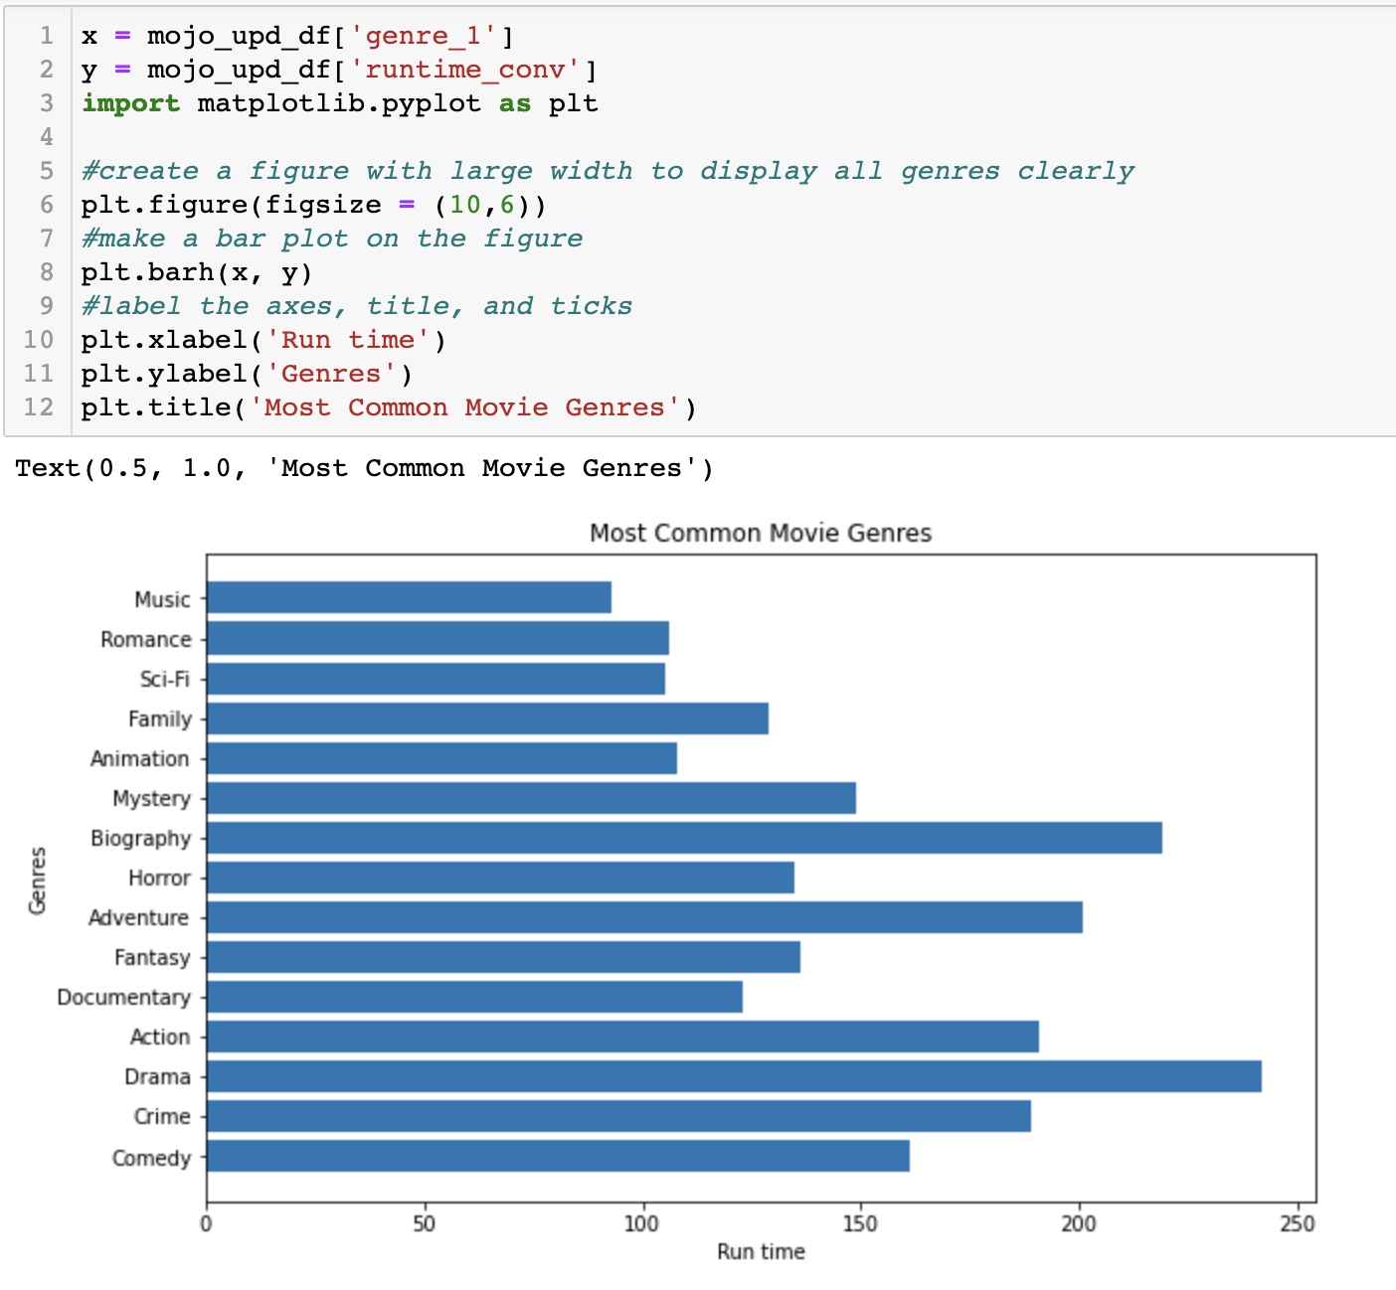

# The box plot has been plotted to see the distribution of runtime data. From the box plot we can see that most of the movies have runtime between 100 to 125 minutes.

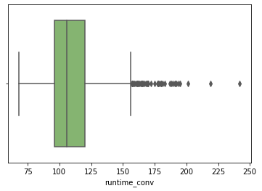

The Count of movies for each content rating is calculated and plotted below. We can see from the graph that movies with rating R are more.

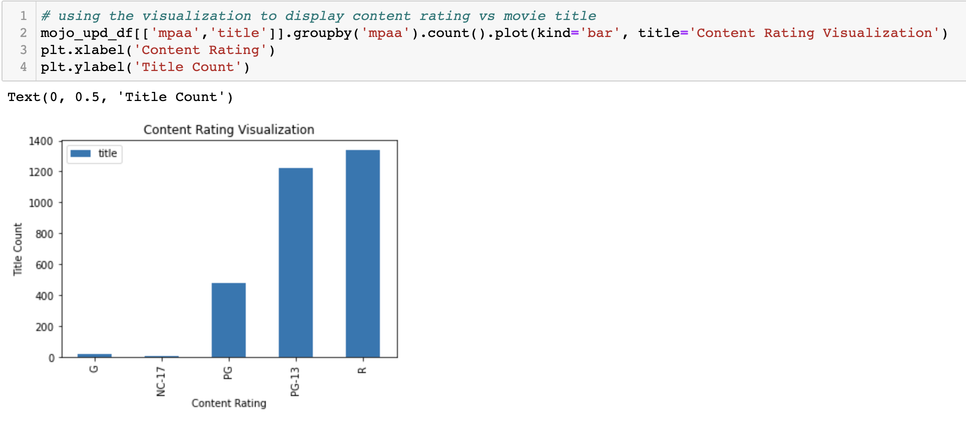

The box plot between content rating and runtime is plotted. We can see that NC-17 and PG-13 have runtime between 100 to 125 minutes.

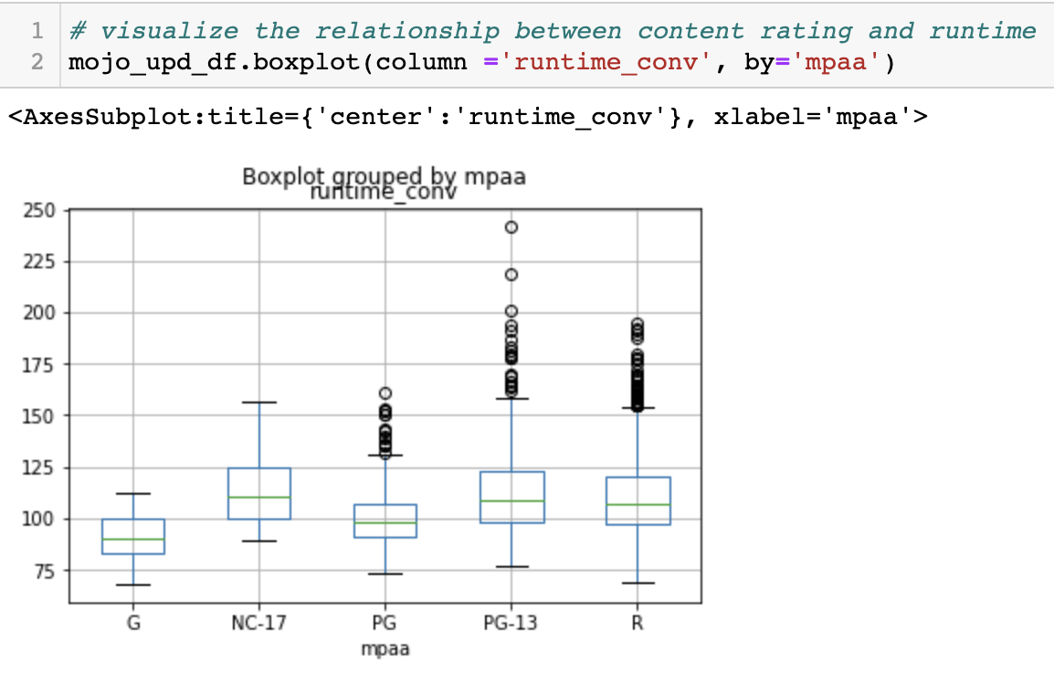

Using Sea born,the release year versus budget has been plotted. The budget for making movies was more in 2017.

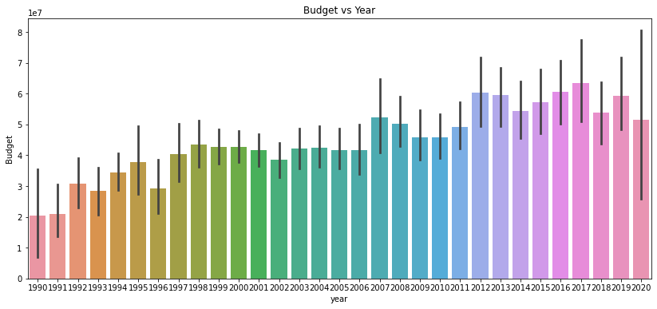

The histogram has been plotted to see how many movies have been released in each year. We can see that more movies have been released in the year 2010.

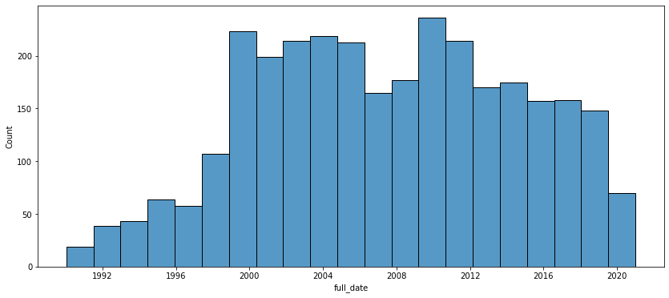

The histogram is plotted to see the count of movies of various genres.

We can see that the count of the Action genre values are more compared to other genres.

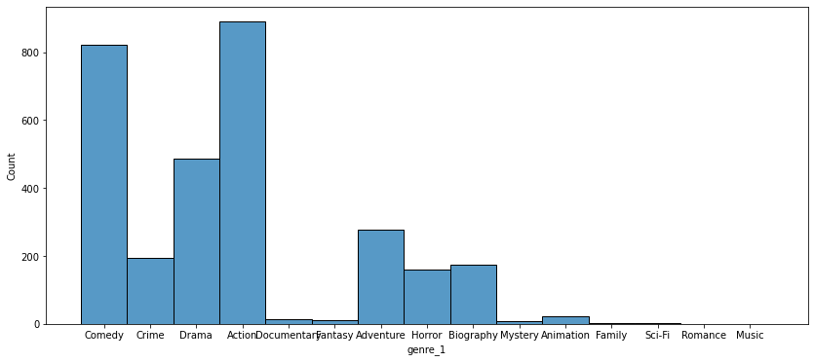

The runtime for various genres is plotted using a line graph.

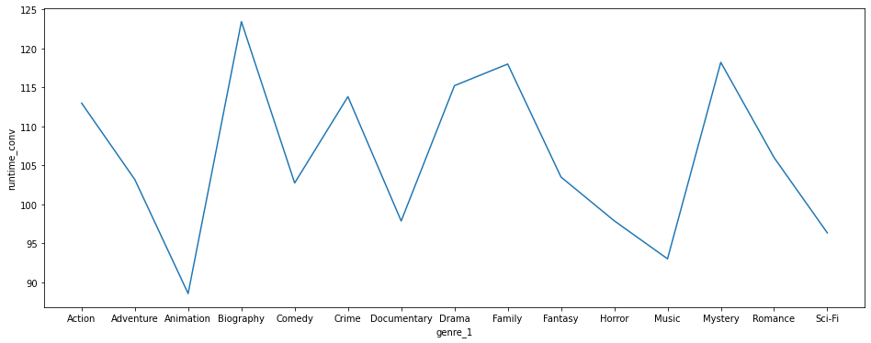

We could see how the budgets of various movies are distributed using the graph below.

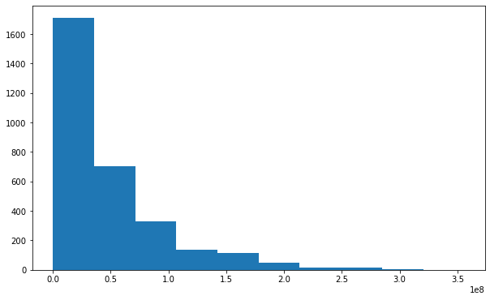

When we describe the dataframe, we can see the following details: the maximum movies are released in the year 2020 and the maximum runtime of movies is 242 minutes.

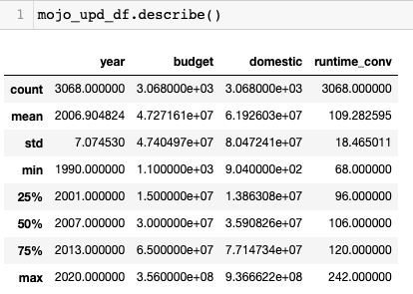

The correlation between numeric columns like runtime, year, budget, and domestic is generated using heatmap. From the heat map we can see that the budget and revenue are highly correlated.

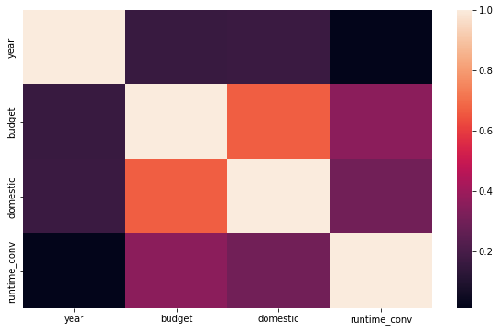

After performing all the conversions like converting the release date to datetime datatype, converting the runtime to minutes, and by removing unnecessary columns, the final cleaned data frame looks like this:

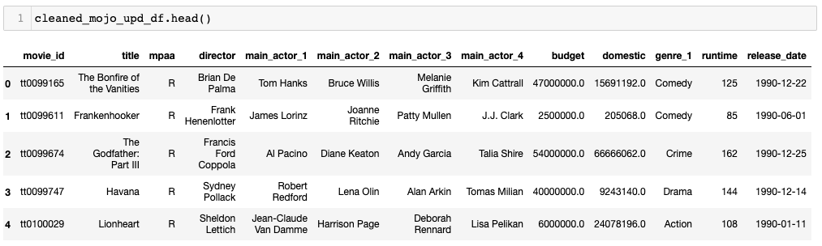

The Exploratory Analysis is done to the Mojo budget update dataset and the data is loaded in the SQLite Database.

# 

# **Database**

The Cleaned Mojo Budget update data is loaded into the SQlite database. The Database contains four tables. Movies_Dable, Genre_Details, Directors_Details, and Mpaa_Details.

The following data will be output for our final database:

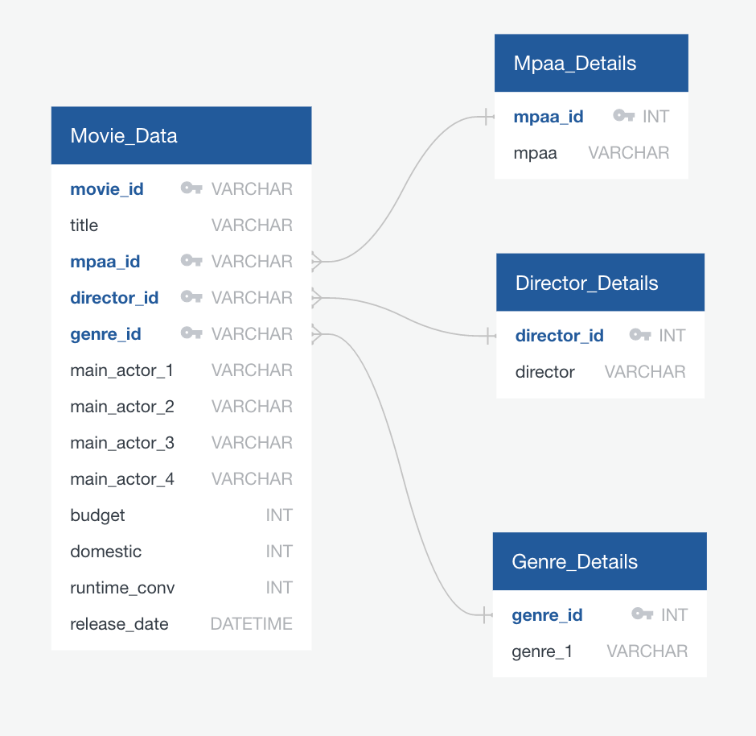

We could see that in the Movies_Data table: movie_id acts as a primary key, which is the unique key whereas mpaa_id, director_id, and genre_id act as foreign keys. We could access the details of mpaa, director, and genre by using these ids from the Movies_Data table.

The Genre dataframe is created by removing the duplicates and the data frame is loaded to the genre_details table.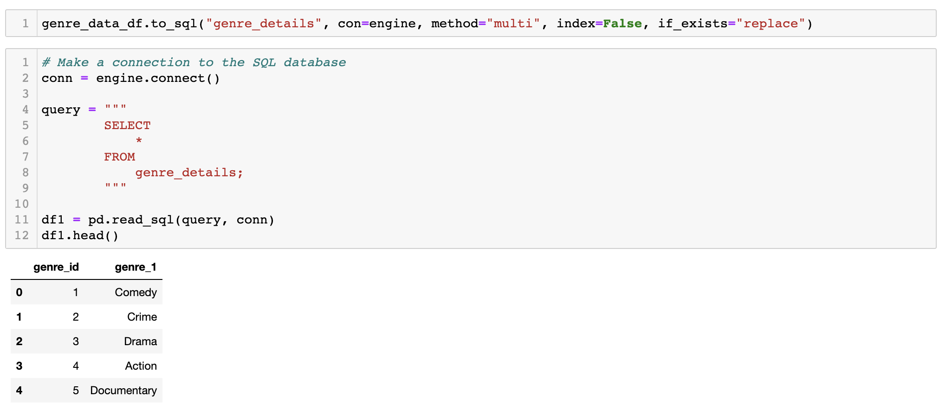

The Director details dataframe is created and the data is loaded into the director details table.

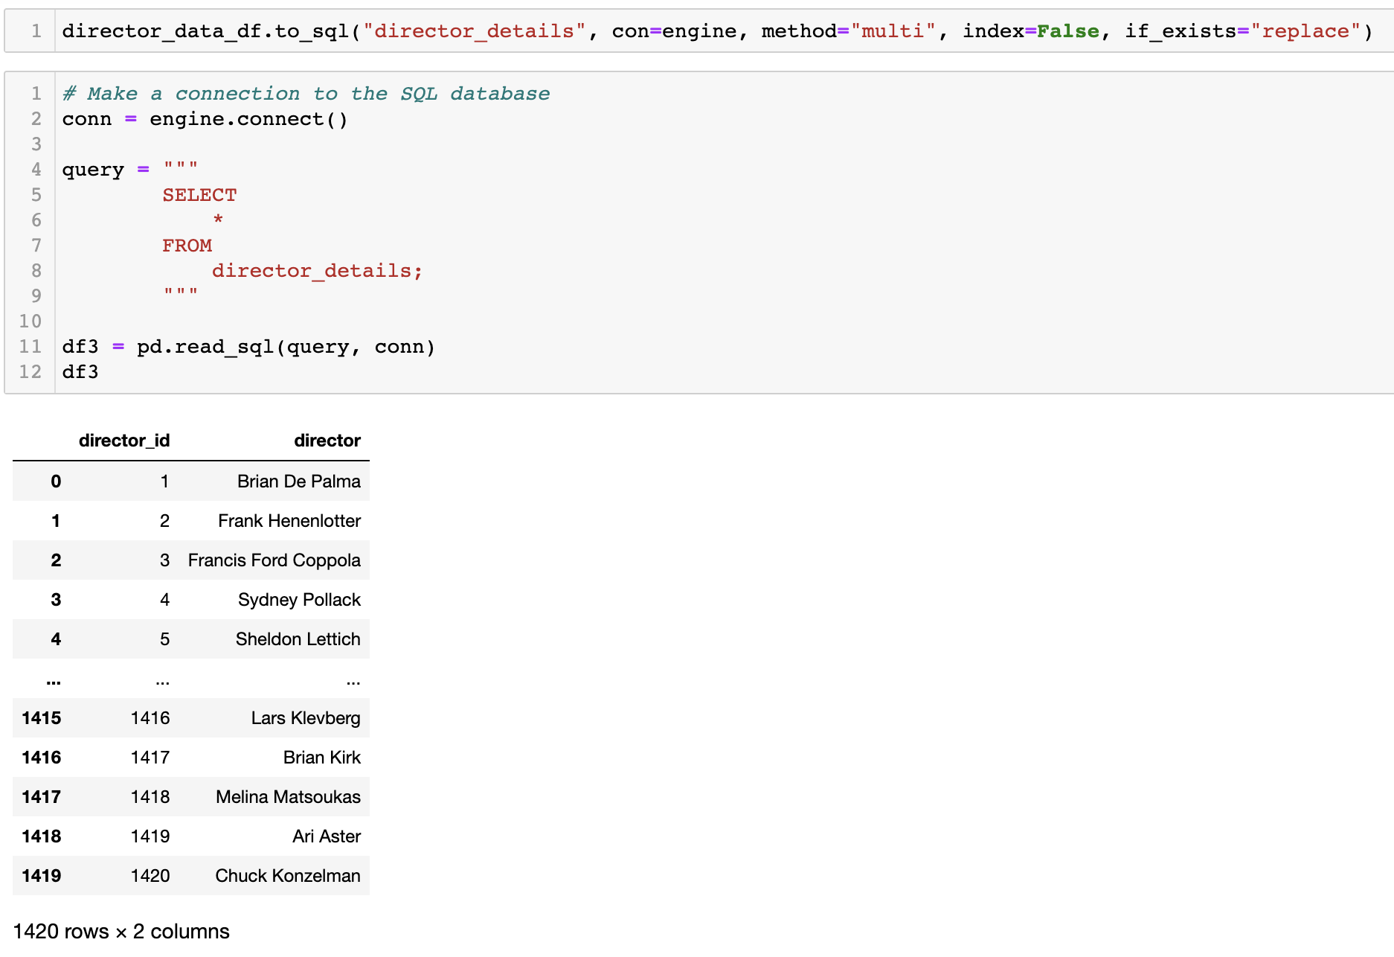

The mpaa dataframe is created and the data is loaded into the mpaa details table.

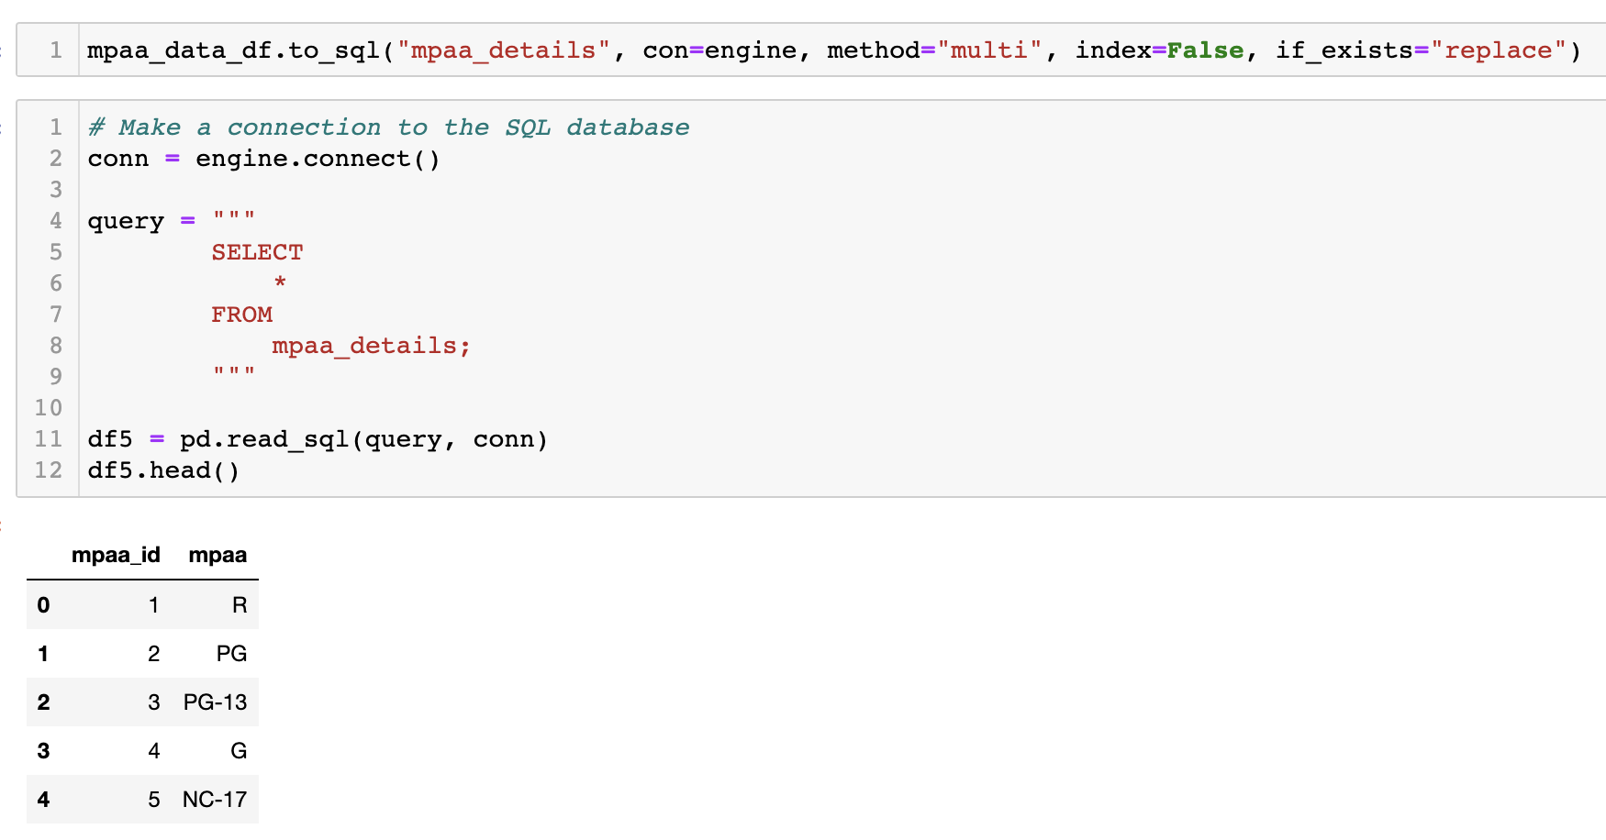

The movies dataframe is created and the movies data is loaded into the movies data table.

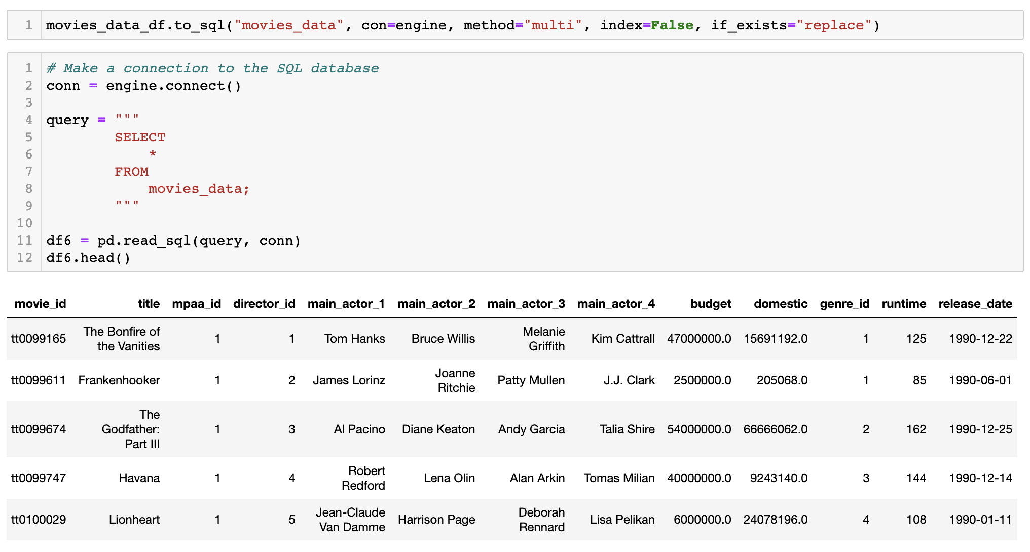

To access the data from multiple tables we could use joins and query the table and get the desired result.

The maximum budget of the movie is calculated by executing the following query:

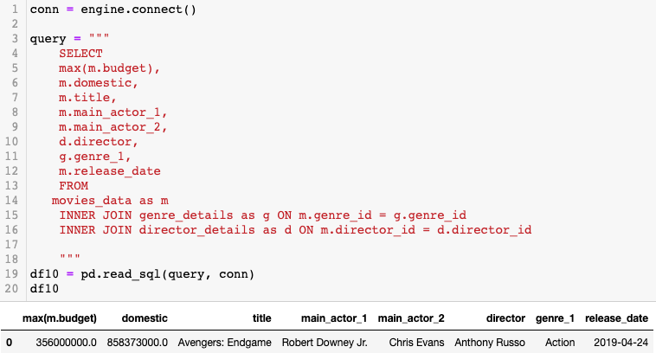

Based upon the genre, release date, minimum and maximum budget specified by the user, the following result is produced by querying the database.

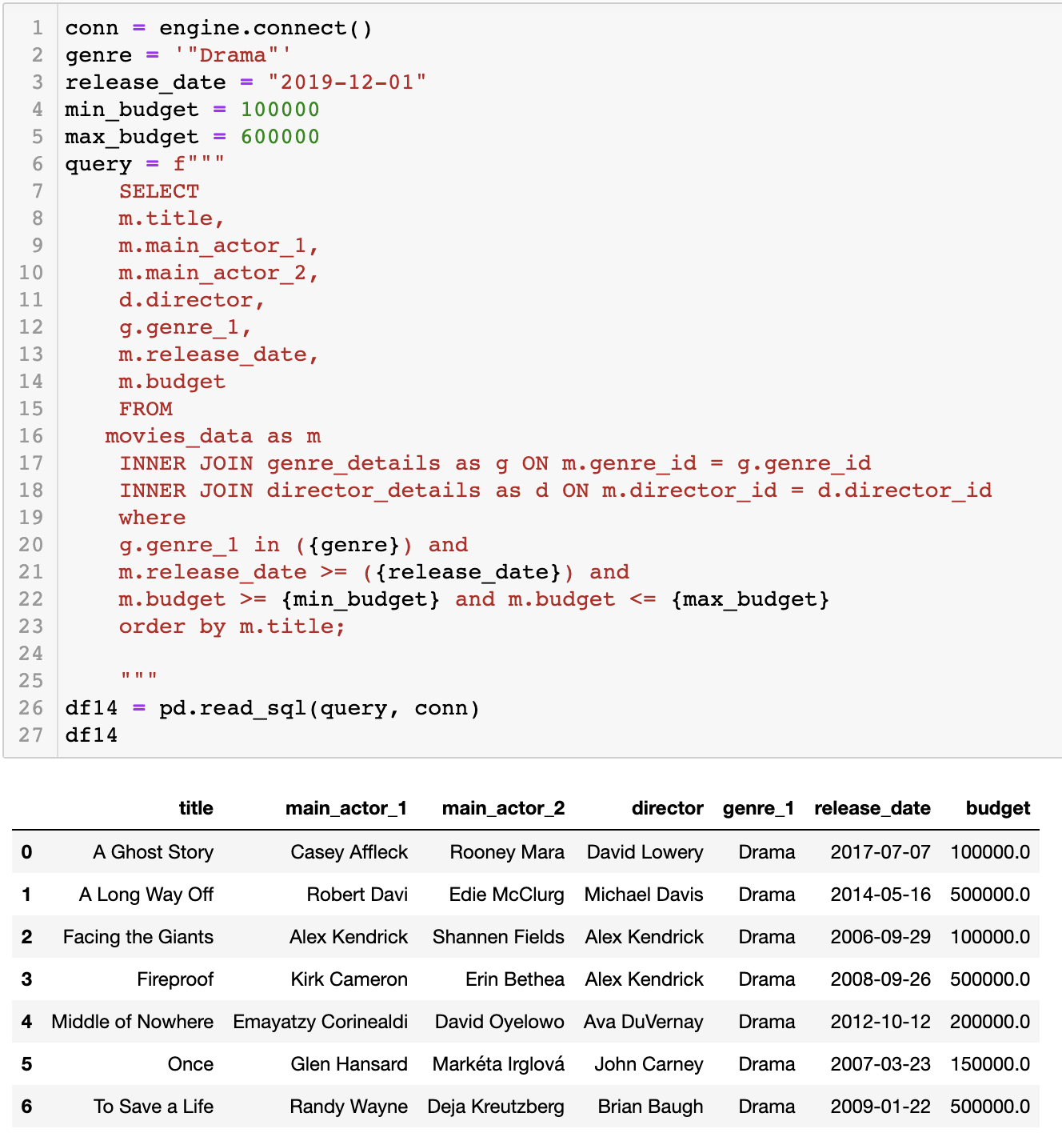

The final database in the website looks like this below: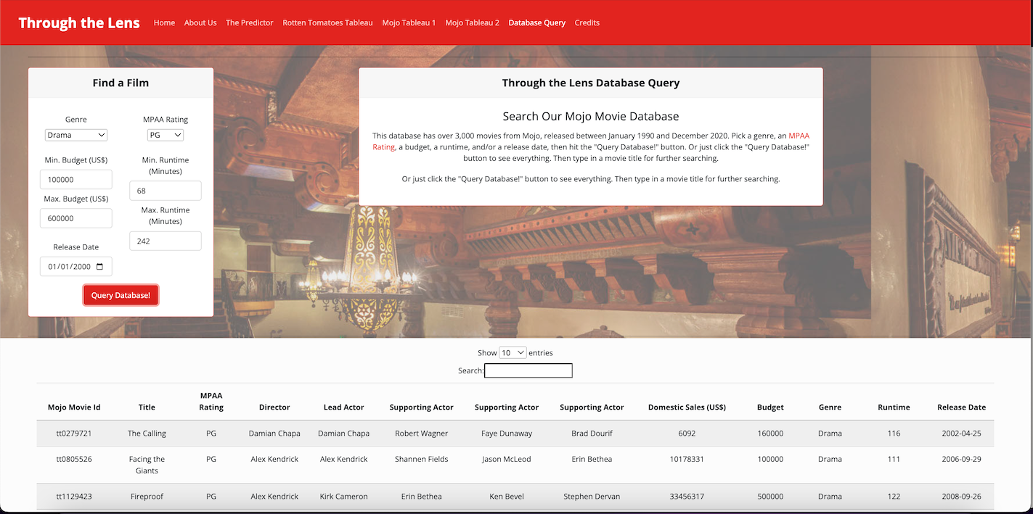

# 

# **Machine Learning**

Predicting the Tomatometer score (critic and audience) for a film based on title length, runtime, production company, actors, authors, genres, and directors.

We tested multiple models and found that audience and critic reactions are difficult to predict reliably. Could this apply to multiple subjective pieces of art?

Our exploration also showcased a high success rating for NR films, which could be attributed to them being classics created before films were rated.

For Machine learning, the Rotten Tomatoes dataset has been used. The dataset has 17712 rows and 22 columns.It has columns like movie title, movie info, content rating, genres, directors, tomatometer rating, and audience rating.

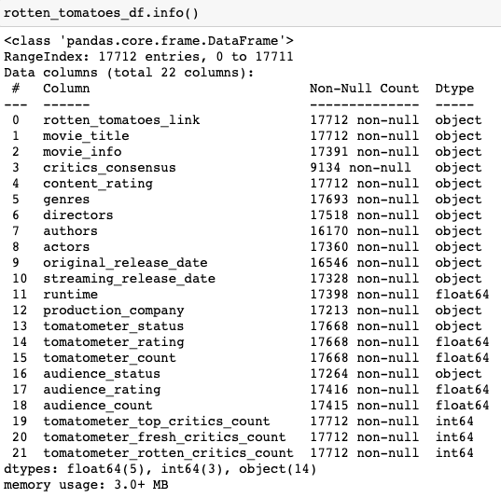

# **Data Preprocessing:**

We need to process the data before performing machine learning.

1. Removing the null values.
2. Dropping the irrelevant columns.

After preprocessing the dataset looks like this below:

# 

Extracting year, month from the release date. Converting all the object data type columns to numeric columns by calculating length of the movie, length of the movie info, number of actors, number of genres, number of directors.

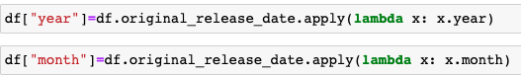

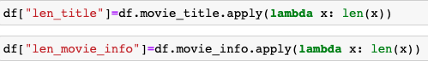

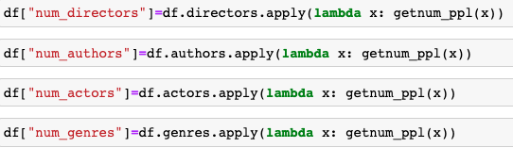

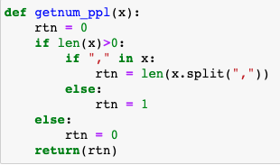

# 



The duplicates in the production company column are removed and then binning is applied as there are more than 10 different companies

.

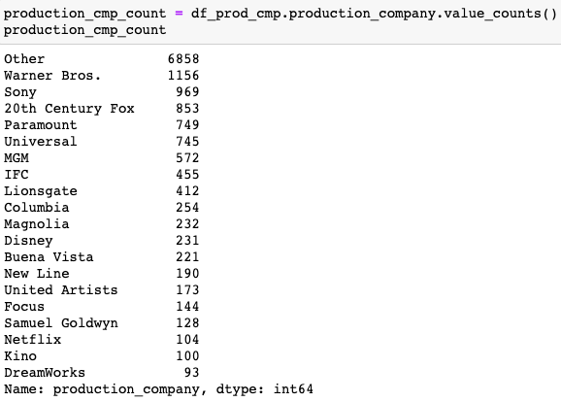

# 

# 

After converting the featured columns to numeric. We need to perform one hot encoding. After that the dataset looks like this:

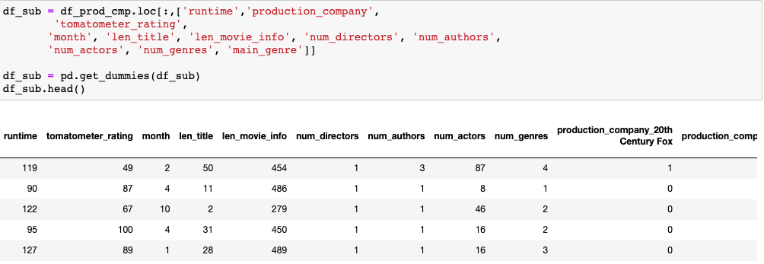

# **Model 1 - Tomatometer Rating as the target column**

# When we plot histogram for tomatometer rating we can see most of the movies are rated between 80 to 100.

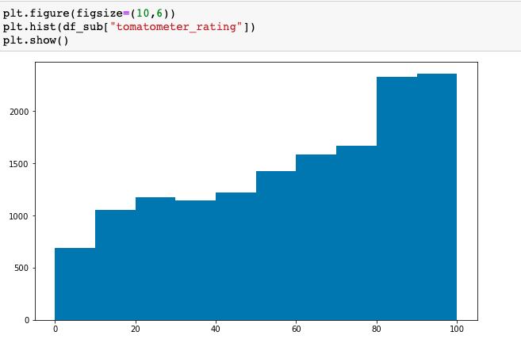

The correlation between tomatometer rating and various columns are found and the values are shown below. We can see that tomatometer rating is correlated with genres, runtime.

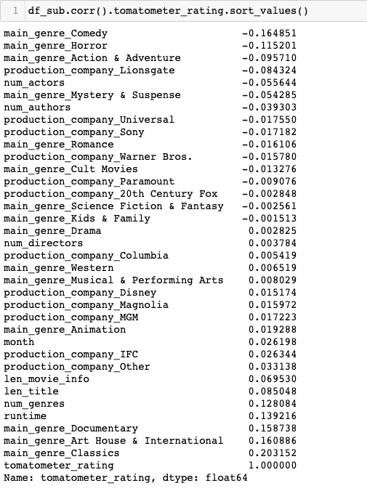

The sea born heatmap shows the correlation between tomatometer rating and various other columns.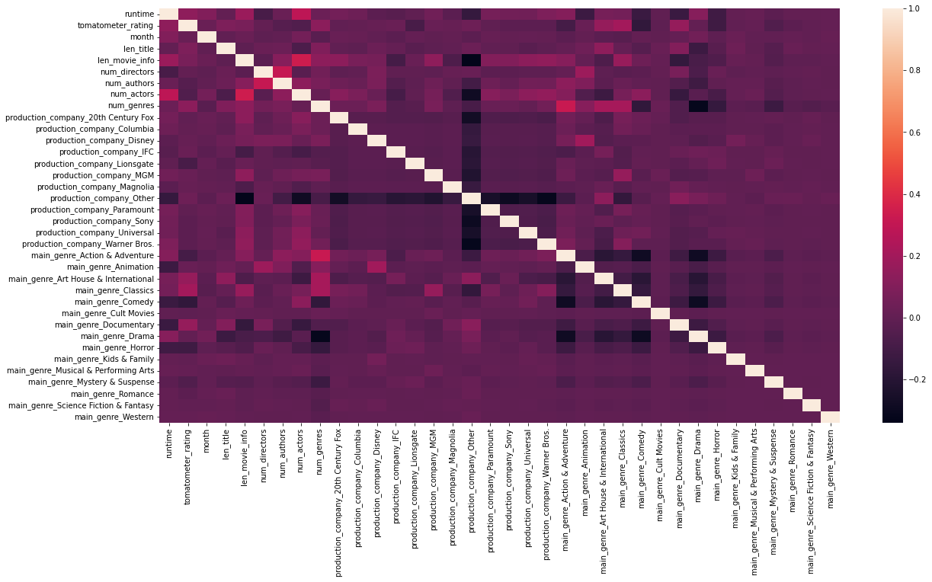

# 

# 

# 

# **Model 2 -Audience Rating as the target column**

Similarly we are going to build a machine learning model for audience rating by following the same steps as we did in tomatometer rating.

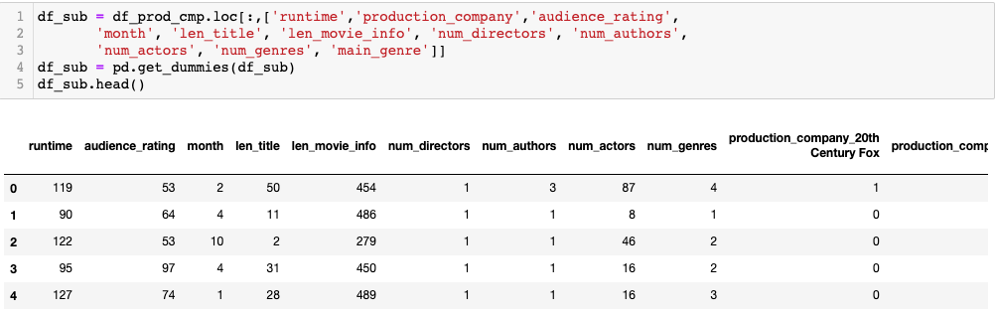

# When we plot histogram for audience rating we can see most of the movies are rated between 60 and 90.

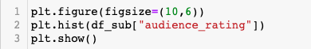

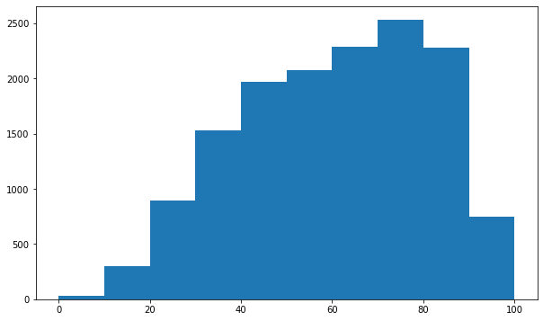

The correlation between audience rating and various columns are found and the values are shown below. We can see that audience rating is correlated with genres, runtime.

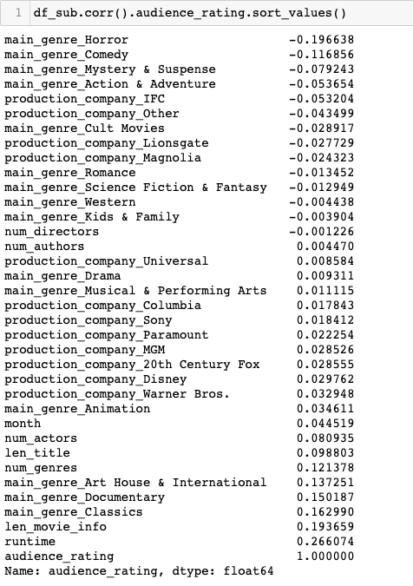

# The sea born heatmap shows the correlation between audience rating and various other columns.

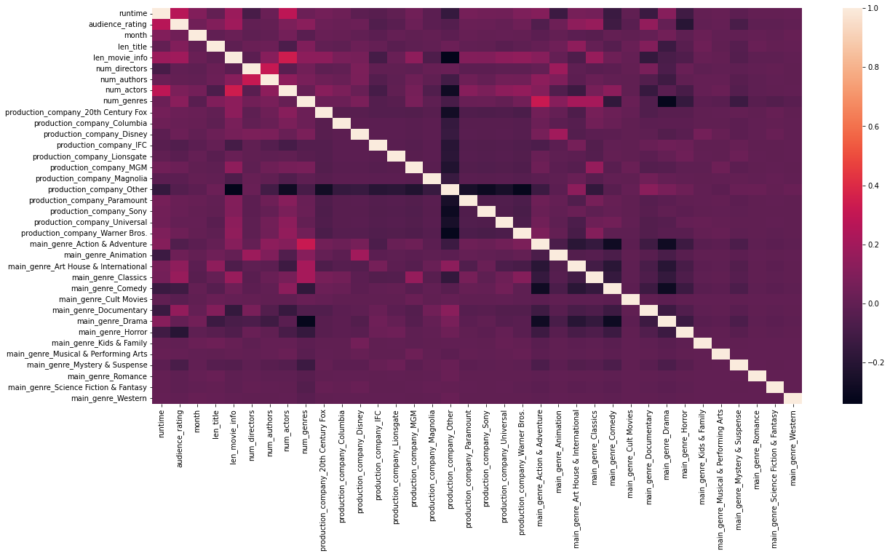

Since we know the target column as the tomatometer rating in model 1 ( audience rating in model 2), we are using supervised machine learning.It deals with labeled data. Supervised machine learning are classified into two types:

1. Classification
2. Regression

Regression is used to predict continuous variables. We want to predict the tomatometer rating in model 1 ( audience rating in model 2) based on movie length,number of actors,number of genres.To accomplish this task, we would collect data on a number of movies. The regression model's algorithms would attempt to learn patterns that exist among these factors. If presented with the data of a new movie, the model would make a prediction of that movie’s tomatometer rating in model 1 ( audience rating in model 2) based on previously learned patterns from the dataset.

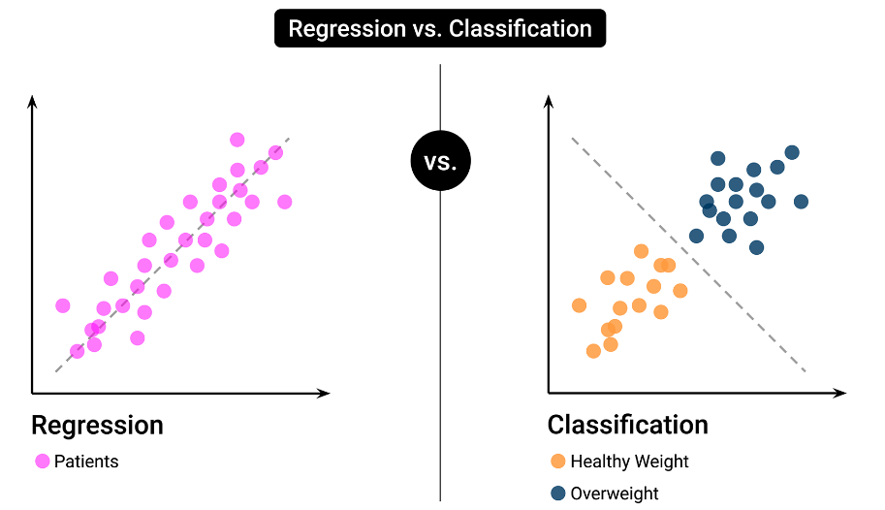A dataset is divided into features and target. Features are the variables used to make a prediction. Target is the predicted outcome. The basic procedure for implementing a supervised learning model: **create a model, train the model, and then create predictions.** We will be using Scikit-learn, a Python machine learning library for implementing linear regression model.

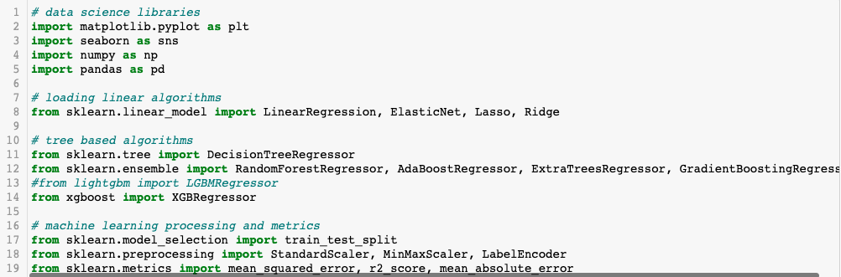

The target variable is tomatometer rating for model 1 (audience rating for model 2) meaning that the goal of the linear regression model is to predict tomatometer rating for model 1(audience rating for model 2) based on the movie length, movie info,genre etc

.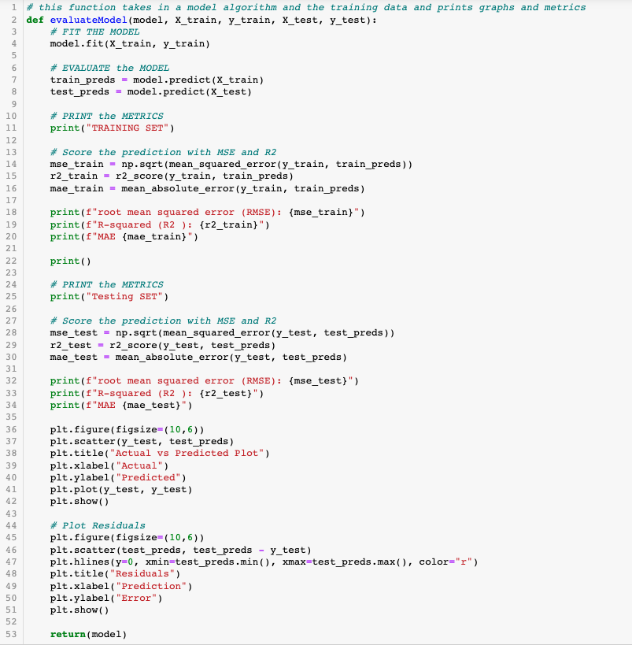

The dataset has been separated into X and y components: X is the input data, and y is the output. We may have noticed that X is capitalized, while y is not,it's a common practice when using Scikit-learn.

The next step is to create an instance of the linear regression model. An object is instantiated, or created, from sklearn.linear_model's LinearRegression class. Instantiation here means that the LinearRegression class is like a template that contains the algorithms required to perform linear regression. From this template, a specific object called model is created that will analyze the data and store information specific to this dataset.After a model is instantiated, it will analyze the data and attempt to learn patterns in the data. This learning stage is alternatively called fitting or training.After the learning stage, the predict() method is used to generate predictions: given any data related to the movie, the model will predict the tomatometer rating for model 1(audience rating for model 2).

**Model 1 - Tomatometer Rating as Target Variable :**

**RESULTS**

**Linear Regression Results**

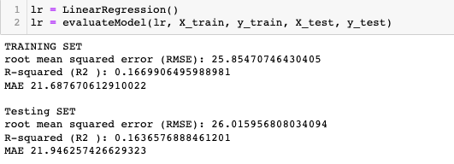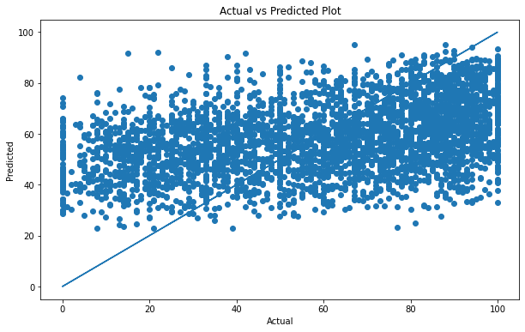

**Random Forest Results:**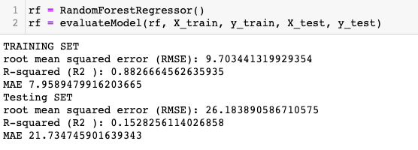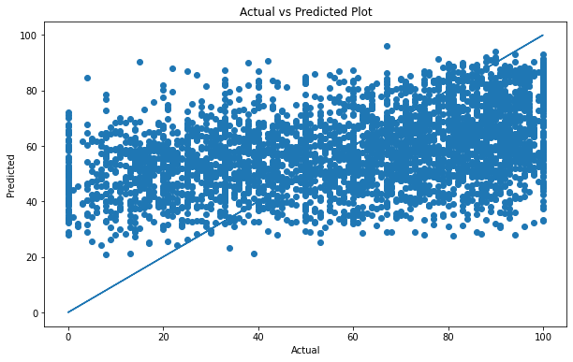

**AdaBoost Results**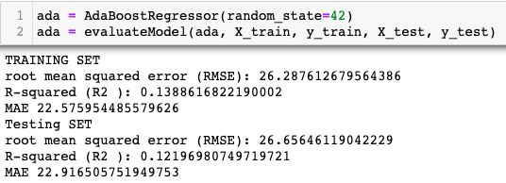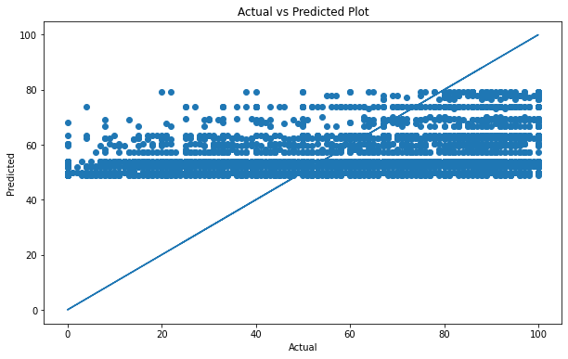

**XGBRegressor Results:**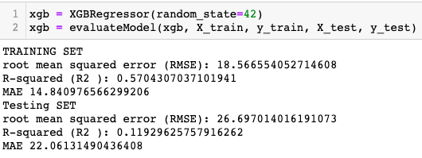

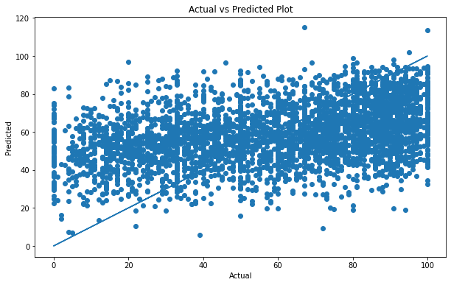

We have trained the same dataset with different models like Ada Boost Regressor, XGB Regressor, Gradient Boosting Regressor. But the R-squared value was less when compared to the linear regression model. **So we have finalized linear regression as our predicted model.**

**Model 2 - Audience Rating as Target Variable : RESULTS**

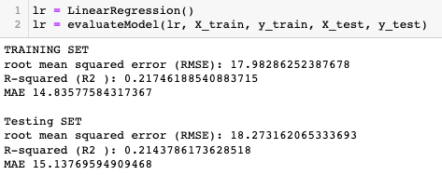

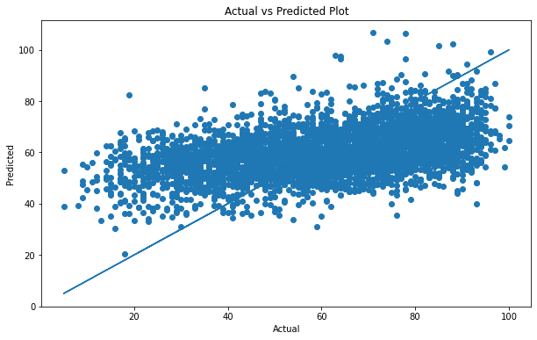

**Random Forest Results:**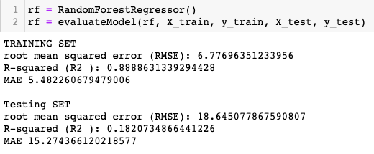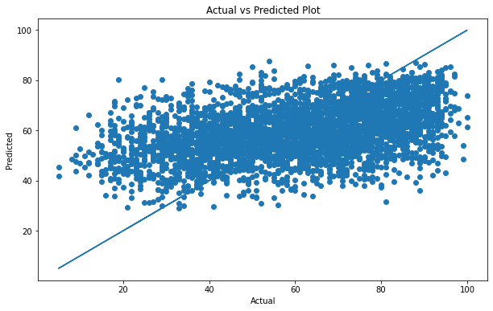

**Ada Boost Results:**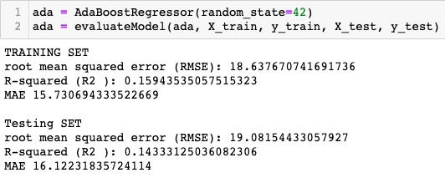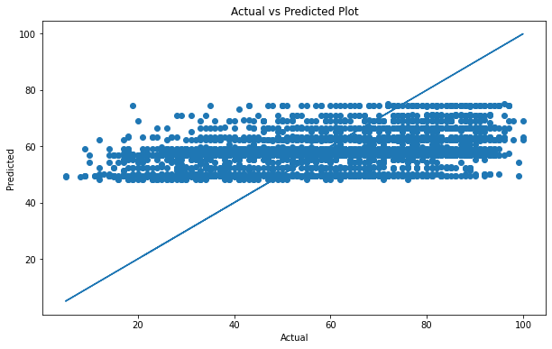

**XGBRegressor Results:**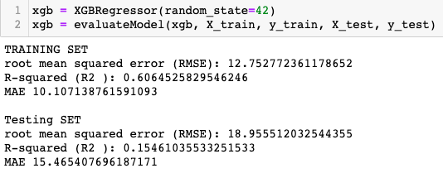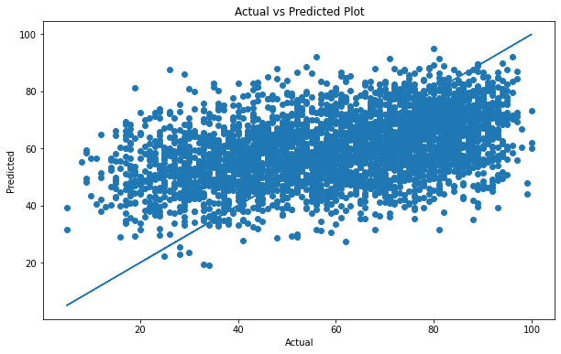

We have trained the same dataset with different models like Ada Boost Regressor, XGB Regressor, Gradient Boosting Regressor. But the R-squared value was less when compared to the linear regression model. **So we have finalized linear regression as our predicted model.**

The final predicted tomatometer rating for model 1 and audience rating for model 2 are merged and added in to a csv file.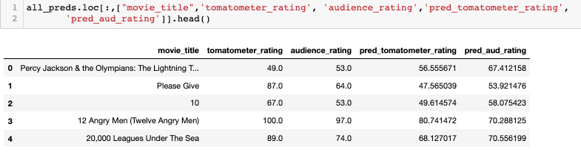**Conclusion:**

We have used various models like Ada Boost Regressor, XGB Regressor, Gradient Boosting Regressor for predicting the tomatometer rating for model 1 and audience rating for model 2. But we could not get the accuracy closer. We used tensor flow too for prediction, but the accuracy was very low there too. We may need to reduce the features and do some feature engineering in the future for better accuracy.

The Machine learning model on the website works like this:

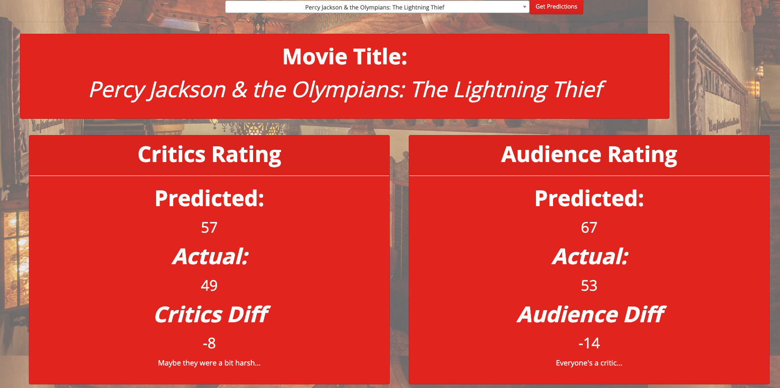

**Tableau**

**Rotten Tomatoes Dashboard**

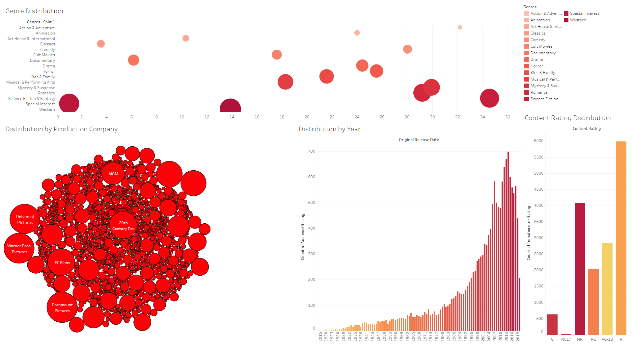

The Rotten Tomatoes Dashboard looks at the number of Rotten Tomatoes reviews by production company, genre, content rating, and date.

Rotten Tomatoes is a highly visited website that captures the critic and audience reviews of the many movies available. The Rotten Tomatoes dataset helped us in identifying trends based on the typical attributes of a movie such as genre, duration, director, as well as production company. We found that the audience rating and the critic rating averages were identical in outcome. The largest gap found when comparing the rating averages were in the Special Interest and Documentary genres. This dataset captured over 17,000 movies in total which gave us a large spread of release dates, even prior to the widespread usage of the world wide web. The content rating distribution showed a significant number of movies which were not rated, which could be due to the fact that content rating did not emerge until 1968 (G, PG, R, & X) and expanded in 1984 to include PG-13.

**Box Office Mojo Dashboards**

Before visualization began, the Box Office Mojo data was cleaned to adjust for inflation. To do this, we used the CPI with guidance from this [**article**](https://towardsdatascience.com/the-easiest-way-to-adjust-your-data-for-inflation-in-python-365490c03969).

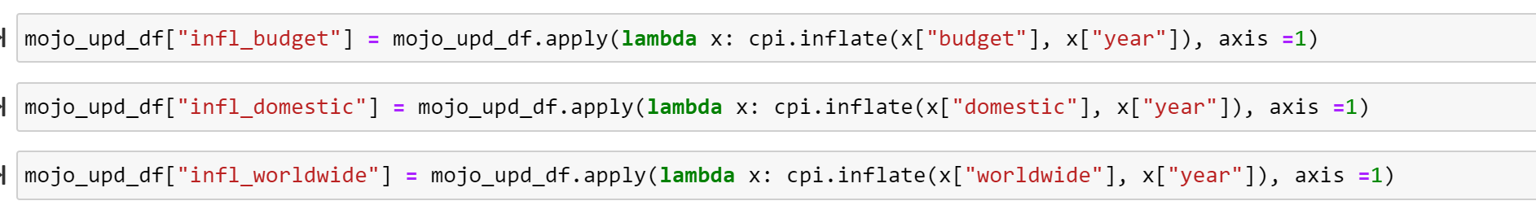

**Box Office Mojo Dashboard 1: Average Profit by: Rating, Genre, Runtime, Director, and Actor**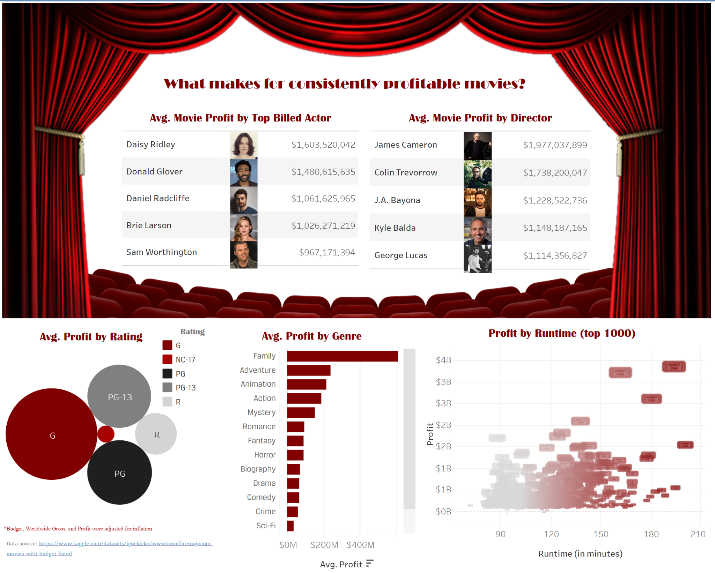

**Overview**

For this first visualization, we chose more static visuals to discover overarching trends in the data. One consistent decision made throughout this dashboard was to base trends on average profit. Utilizing the sum of profit would skew the top actors and directors to those with longer careers. The exception was for ‘Profit by Runtime,’ which has the top 1000 films by profit plotted individual.y.

**Analysis**

At the top, the first two visualizations explore the top actors and directors by average profit. These visualizations forced us to learn the names of the directors for all the new *Jurassic World* films, along with some un-surprising names (George Lucas, for example.) The actors, however, left me with a few major questions:

1. Donald Glover is fantastic, but his name was unexpected at the top of the list.
   1. Donald provided the voice for Simba in the modern remake of The Lion King, which had a large profit. Donald isn’t billed as the first actor for many films, so his stock rose.
2. Sam Worthing-who?
   1. *Avatar*’s lead actor. He has other leading credits to his name, but this most certainly skewed his position.
3. Would a film starring Daisy and Daniel be an automatic money-maker?

The obvious take-aways from both of these visualizations are that franchises seem to be the key to a high average box office - Harry Potter, Jurassic World, and Star Wars reign both lists.

The bottom 3 visualizations tell two distinct stories. Average profit according to ratings and genre indicate that the broader your audience, the more likely your film is to be profitable. G ratings and the Family genre top the list.

The visualization demonstrating average profit by runtime supports the theory that a successful film is most likely going to be a franchise or big budget remake. The visualization shows the top 1000 films, and a vast majority of the films fall in a brick near the center, demonstrating that runtime does not appear to significantly impact profit.

**Next Steps**

These visualizations provide a fascinating jumping off point that could prove useful if a soulless Hollywood executive wants to seek consistently profitable directors and actors. One way to deepen the analysis would be to incorporate the number of films as some type of filter. That *Avatar* guy struck gold once, but who knows if he’ll manage it again?

It could prove interesting to expand the actors selection to include more than just top billing versus average profit. Another style of visualization could provide something more interactive to narrow parameters and find that perfect actor to match a project.

**Box Office Mojo Dashboard 2: Profit vs Budget Interactive Dashboard**

**Overview**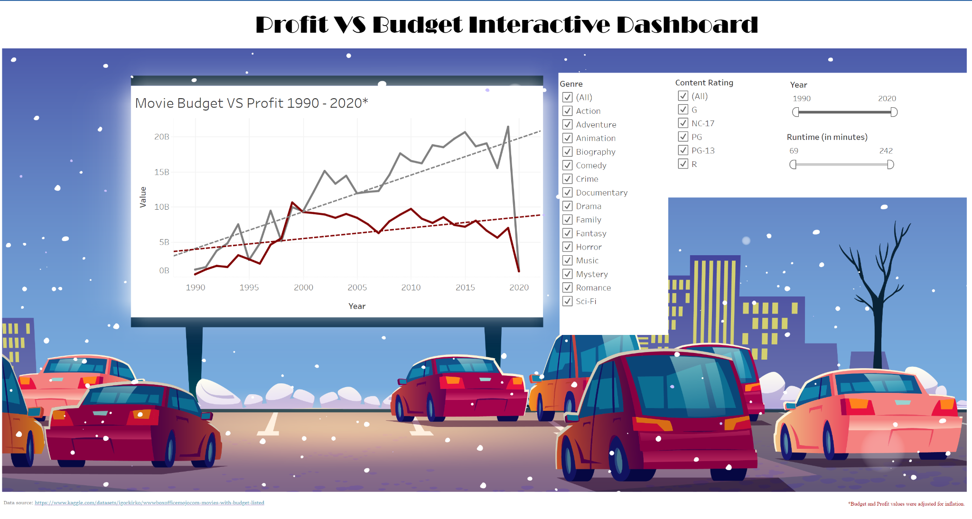

This interactive dashboard is designed to be an accompaniment to the first Box Office Mojo dashboard. Users can bring all their questions to this interactive dashboard and look at profit trends over time, including genre, content rating, year, and runtime.

**Analysis**

In its static form, the interactive dashboard shows an ongoing trend of movies yielding more and more profitable films as time goes on, with an interesting point in the late 90s where it would appear the industry was not profitable overall. There’s a (to be expected) dropoff where the data ends in 2020, when the industry was put in a chokehold.

**Next Steps**

This dashboard would likely benefit from more data as well - perhaps awards data or ratings data could be integrated to create a more dynamic chart.

**Conclusions**

The Box Office Mojo Tableau dashboards seem to highlight this long-standing issue within the movie industry: franchise films or familiar concepts seem to out-perform the rest. Now this begs the question - are data-driven filmmaking decisions poised to demolish artistry? Has it already?

To deepen the analysis, it would be interesting to tie together audience and critic ratings, alongside the budget and profit analysis. Breaking things down further by studio could bring another layer of depth. Which studios are playing it safe and which are less risk-averse? Finally, it would be useful to see how certain films are performing on streaming versus at the movie theater. Is streaming killing the movie theater? Are movie theaters going the way of the dinosaur? There are so many more questions to answer with this data.

**Web Application**

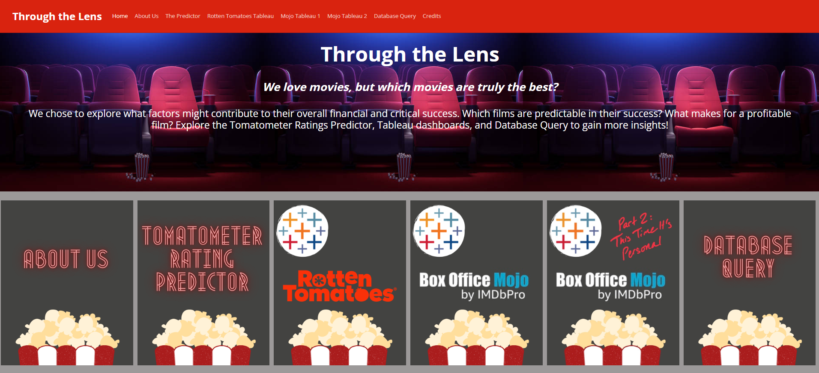

The Through the Lens website was built and launched utilizing VS Code, Jupyter Notebooks, Flask, and Heroku.

The final product of this project is the above [website](https://through-the-lens.herokuapp.com/), which includes the following sections:

**About Us**



* Meet the team who worked on Through the Lens!

**The Predictor**

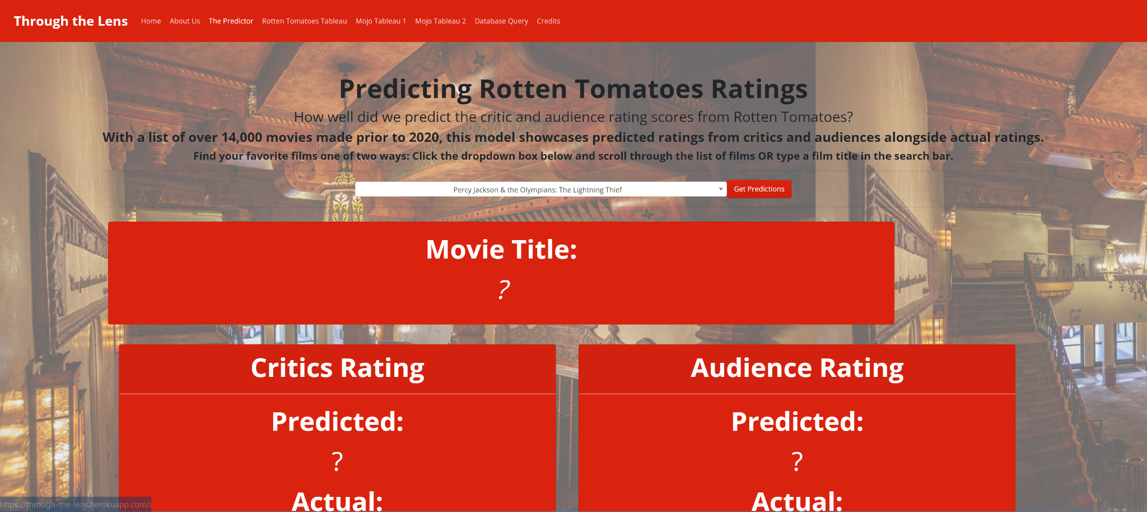

* Use our machine learning model to predict the audience and critic Tomatometer (Rotten Tomatoes) scores from a list of 14,000+ movies. You can also see the film’s actual score to see how well our machine predicts critical behavior.

**Database Query**

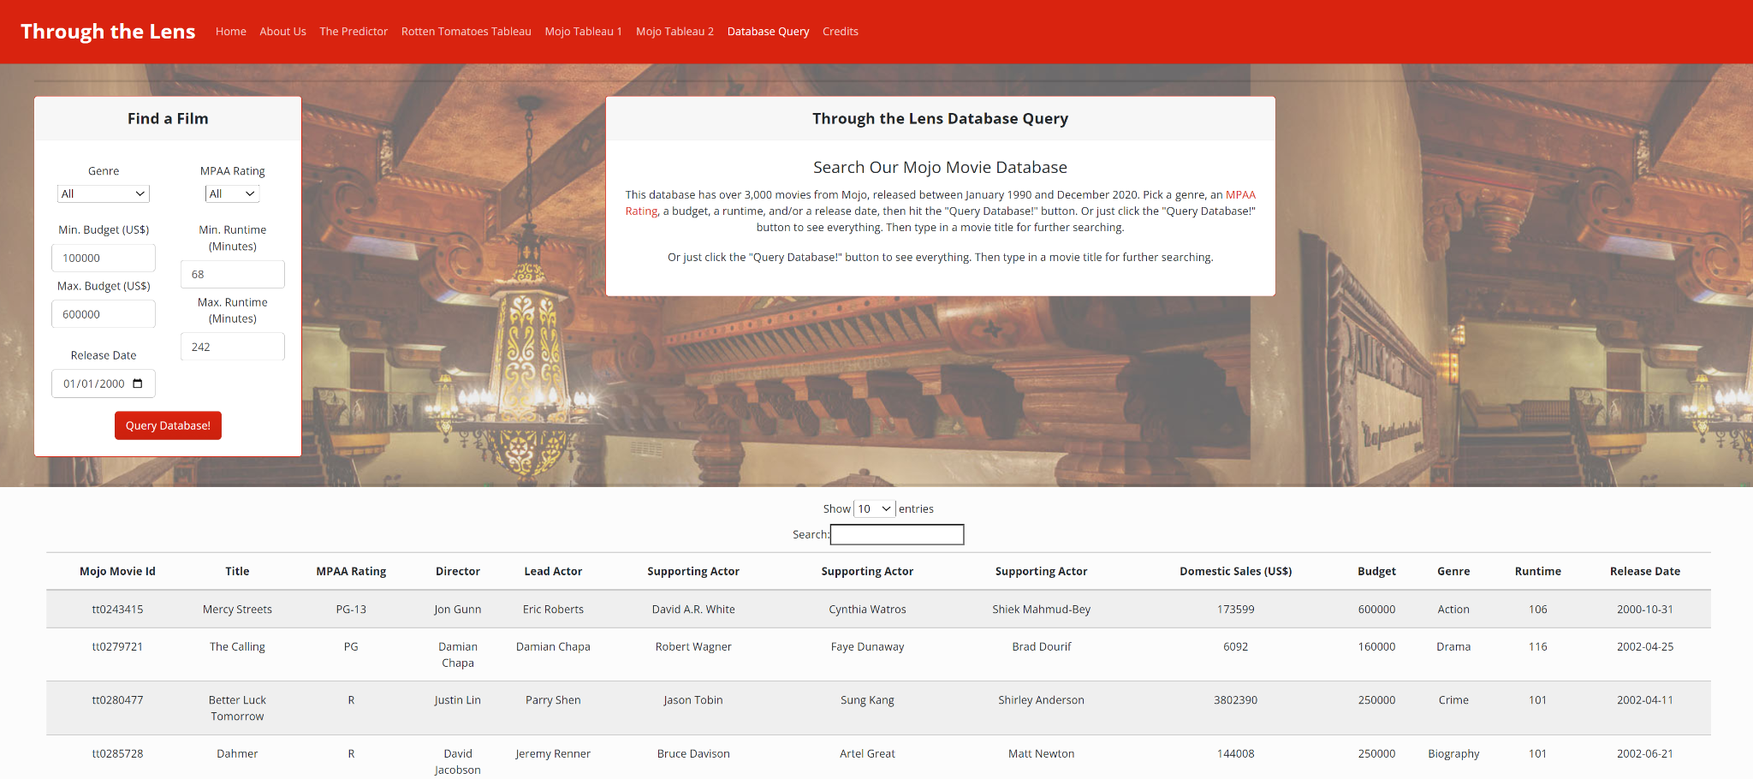

* Filter through the Box Office Mojo Data and explore the budget data.

**Rotten Tomatoes Tableau**

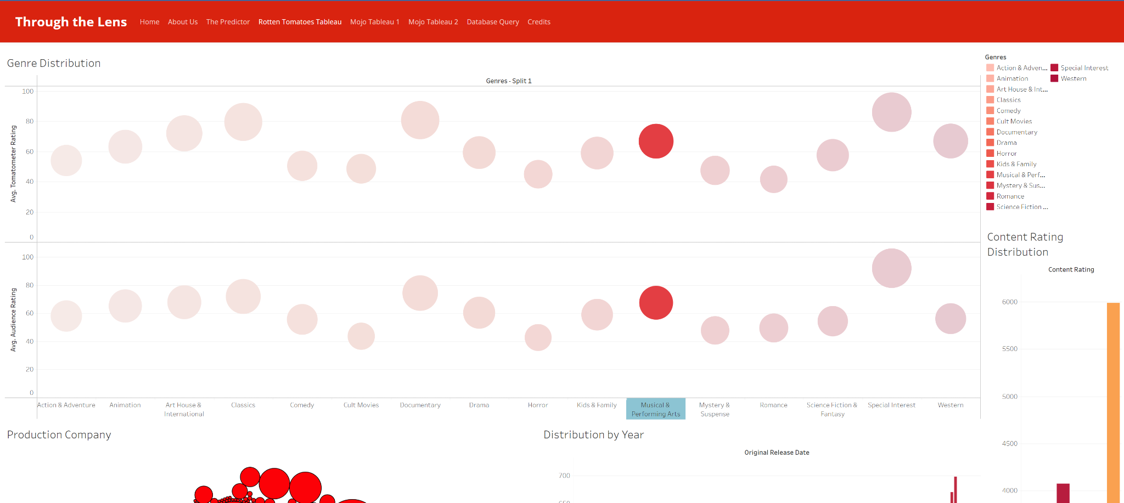

* + See the evolution of Rotten Tomatoes, exploring the number of reviews by genre, studio, over time, and by content rating.

**Mojo Tableau 1**

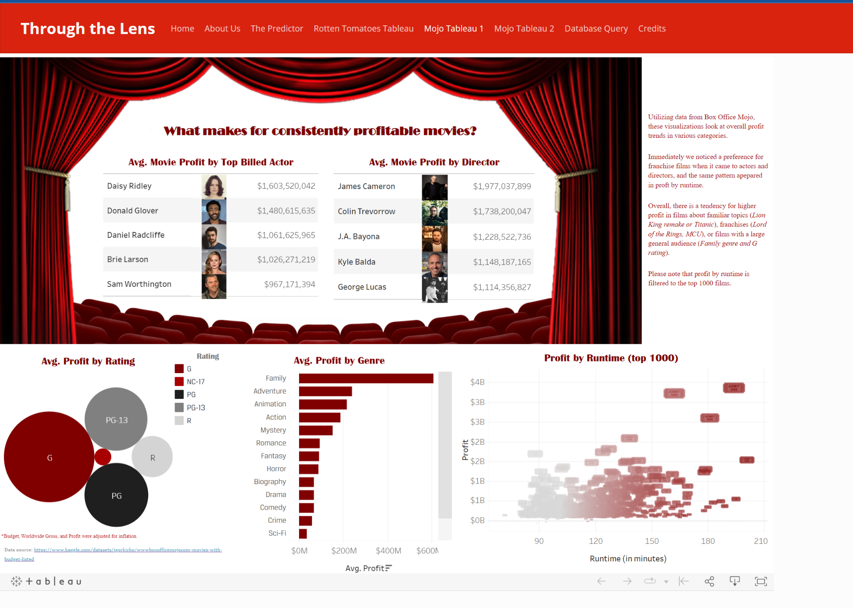

* + Start with the static dashboard exploring the average profit by top billed actor, director, content rating, runtime, and genre.

**Mojo Tableau 2**

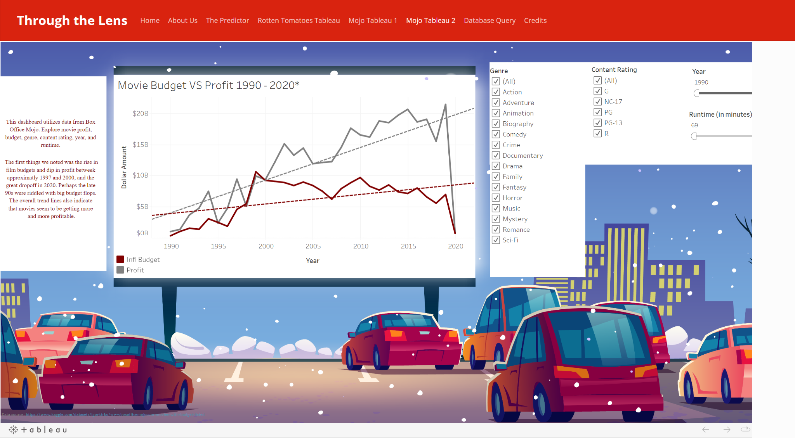

* Explore the Box Office Mojo data further, exploring film budgets and profits over time with filters for content rating, runtime, and genre.

**Credits**



* See our resources.

Background images and buttons for our pages were sourced or created via Google, Adobe Stock, or Canva. One important note is that the background image on the machine learning page The Predictor and Database Query is from team member Jaime’s hometown. She frequented the theater as a child and was struck by its old school charm and beauty.

# **Conclusions**

Our analysis genuinely concluded that human behavior can be difficult to predict, especially when it comes to their reactions to art and that franchises / familiar properties tend to dominate at the box office.

To deepen the overall analysis, the first thing we would do is tie together our data, connecting the financial and Rotten Tomatoes data, and perhaps pull in some additional ratings data. Seeing how these metrics interact might help us understand audience and critic behavior on a more meaningful level.

The Box Office Mojo Tableau dashboards seem to highlight this long-standing issue within the movie industry: franchise films or familiar concepts seem to out-perform the rest. Now this begs the question - are data-driven filmmaking decisions poised to demolish artistry? Has it already? Perhaps the data could help figure out ways to make new media that has a lessened risk without the promise of a big box-office payout.